**Setup Mediawiki LAMP stack using AWS CFT & Ansible**

**GitHub Repo –**

https://github.com/myk-vj/Mediawiki.git

**IAM Role –**

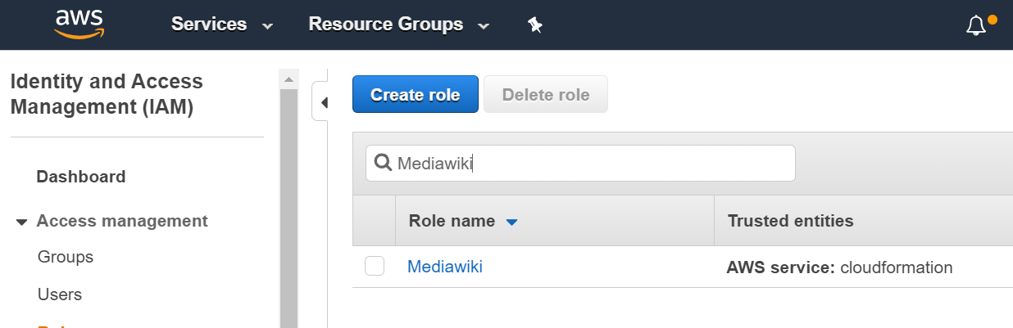

**EC2 Key Pair –**

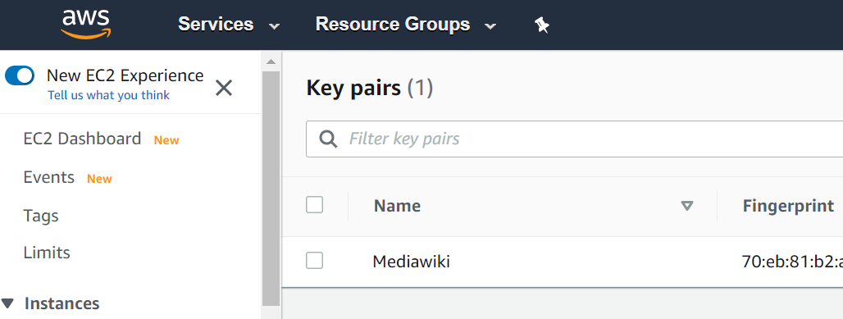

**CloudFormation Stack Designer –**

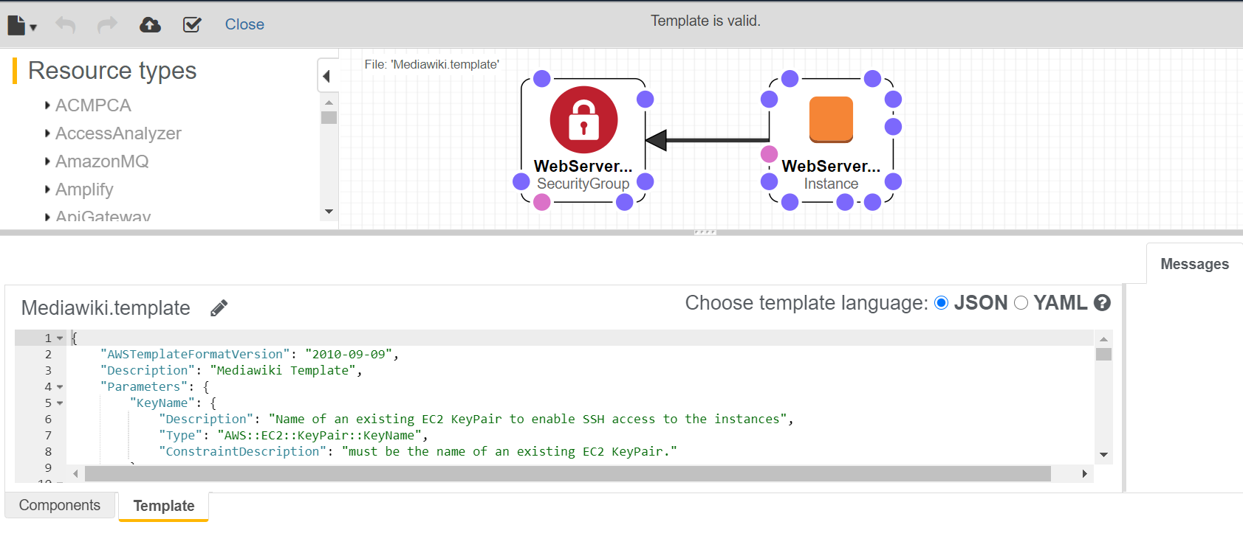

**Stack Creation –**

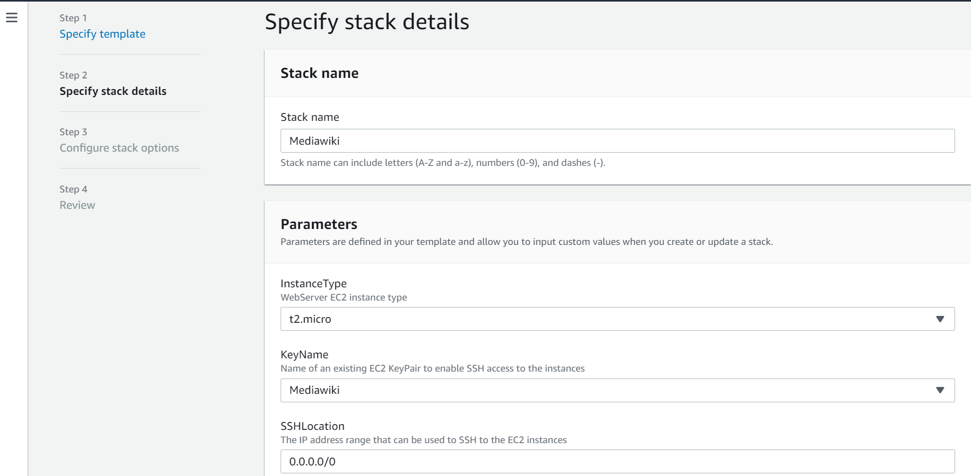

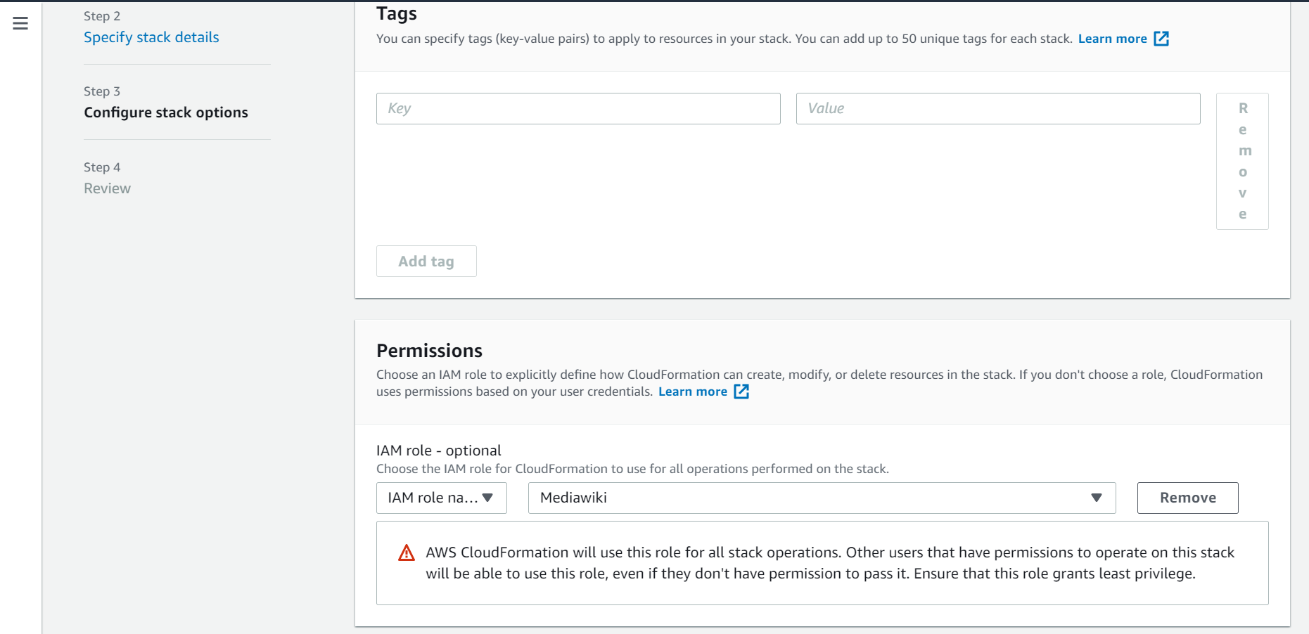

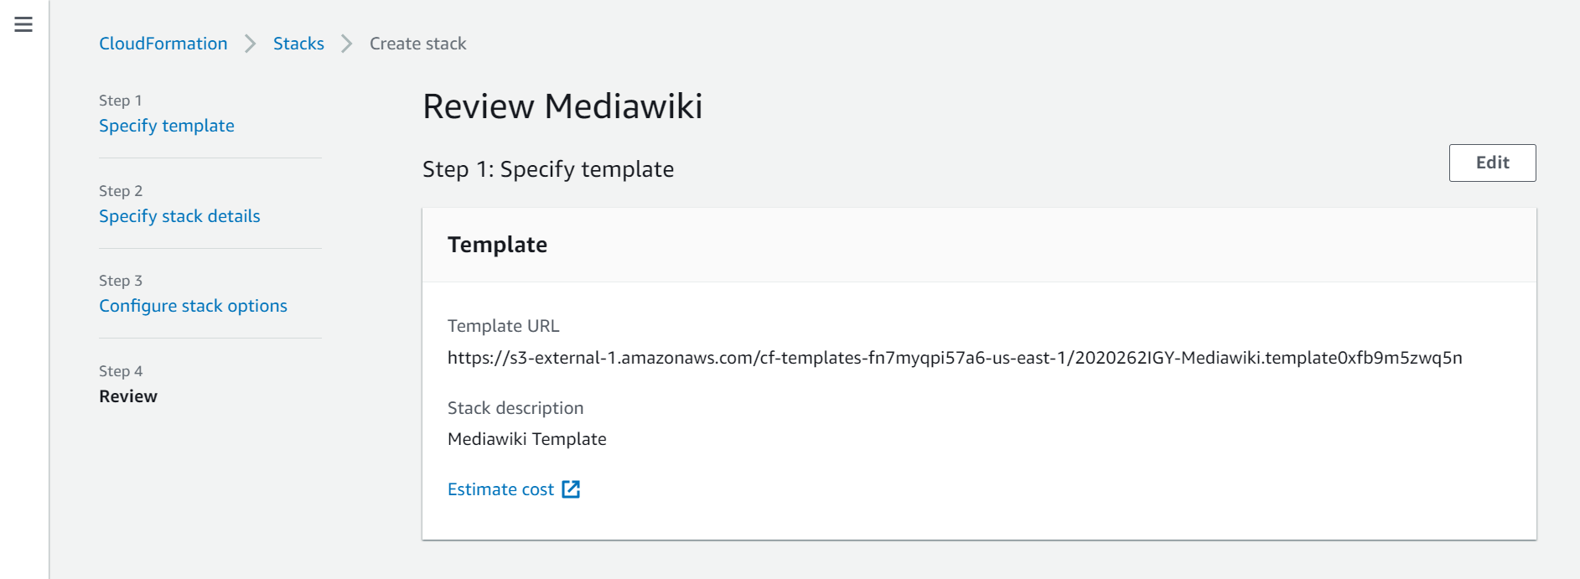

**Creation - Completed**

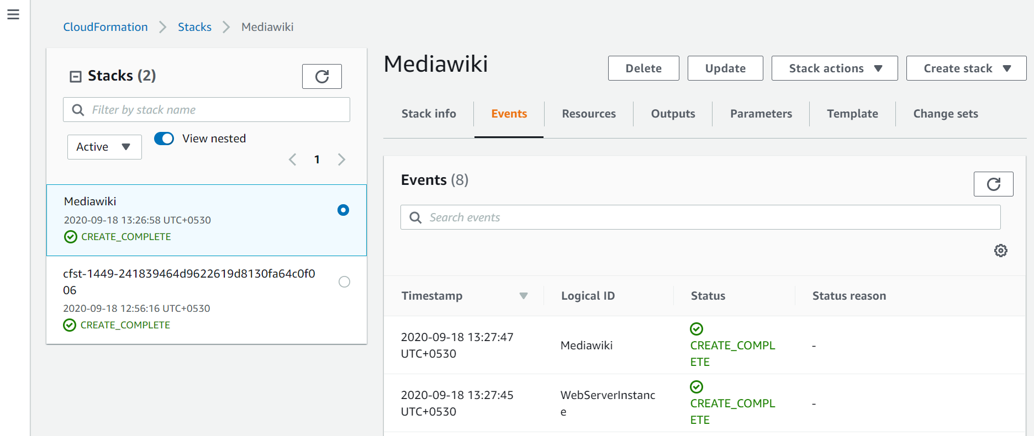

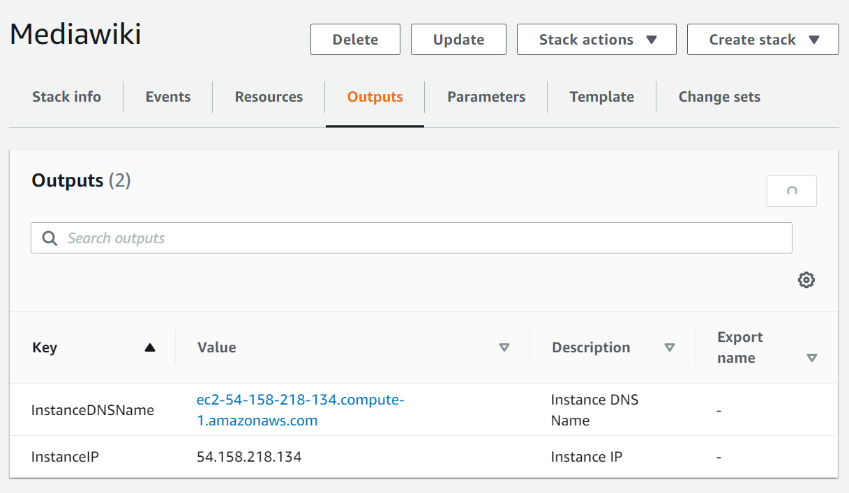

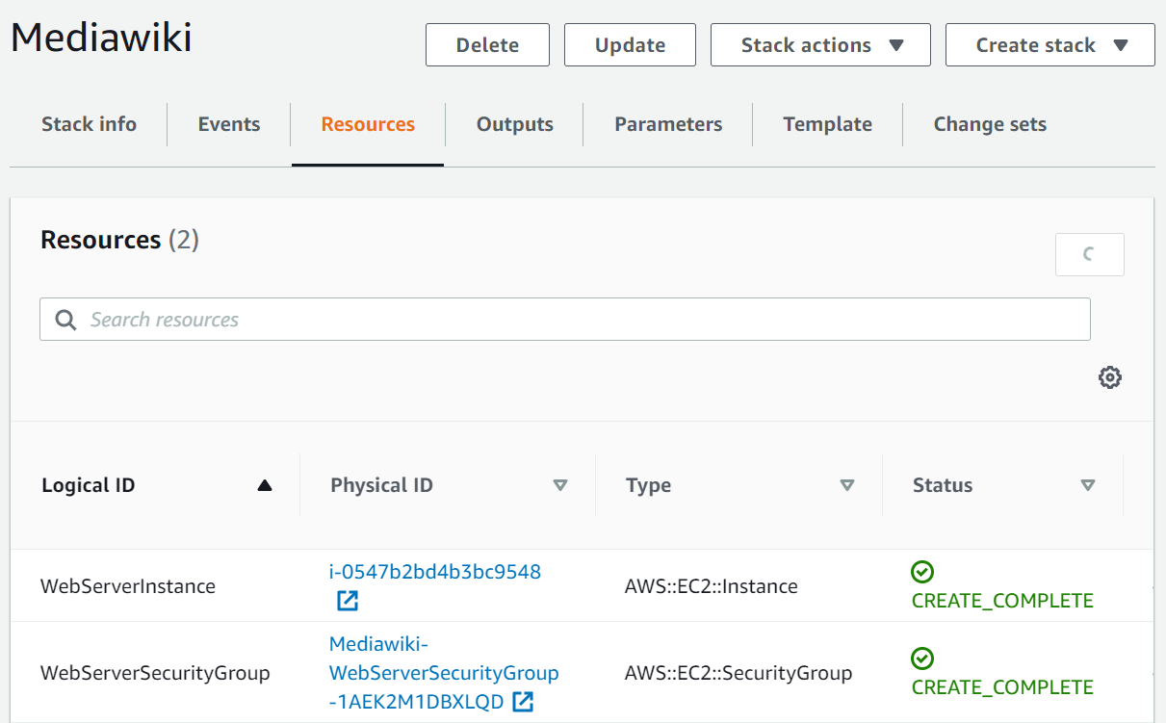

**Monitor cloud initialization from** /var/log/ cloud-init-output.log

After few minutes (~6-7 mins) –

* Yum repo will be up to date
* Ansible, Python, Git will be present
* On ec2-user user home process will pull the Ansible repo and execute it to install/configure LAMP stack

**Results –**

Details from EC2

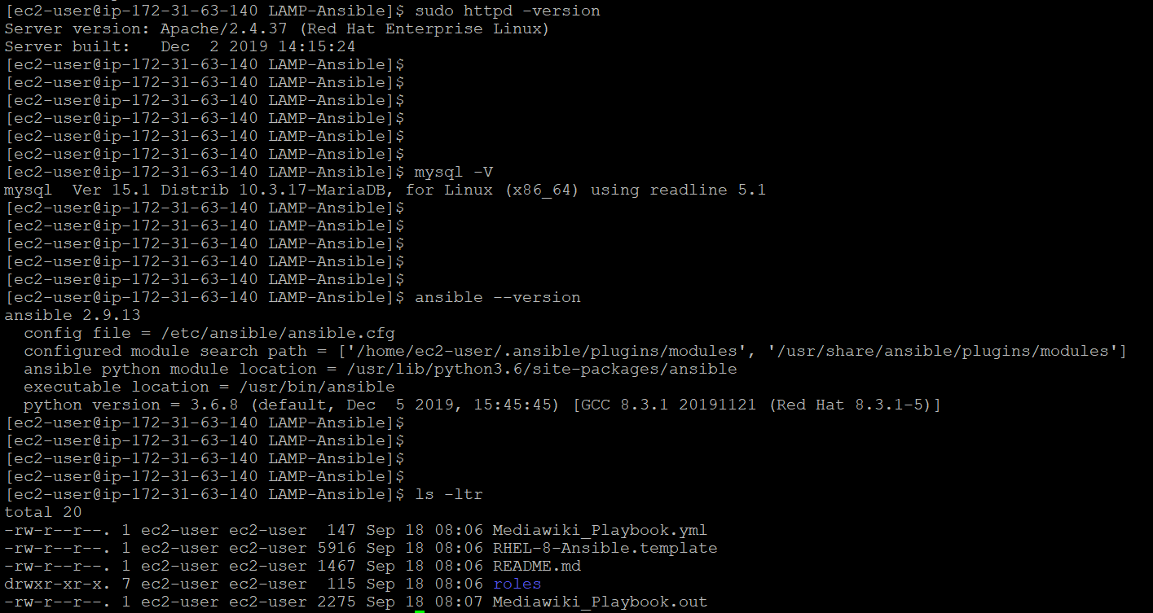

To test, from browser try accessing http<IP>:80/mediawiki

Apache Home

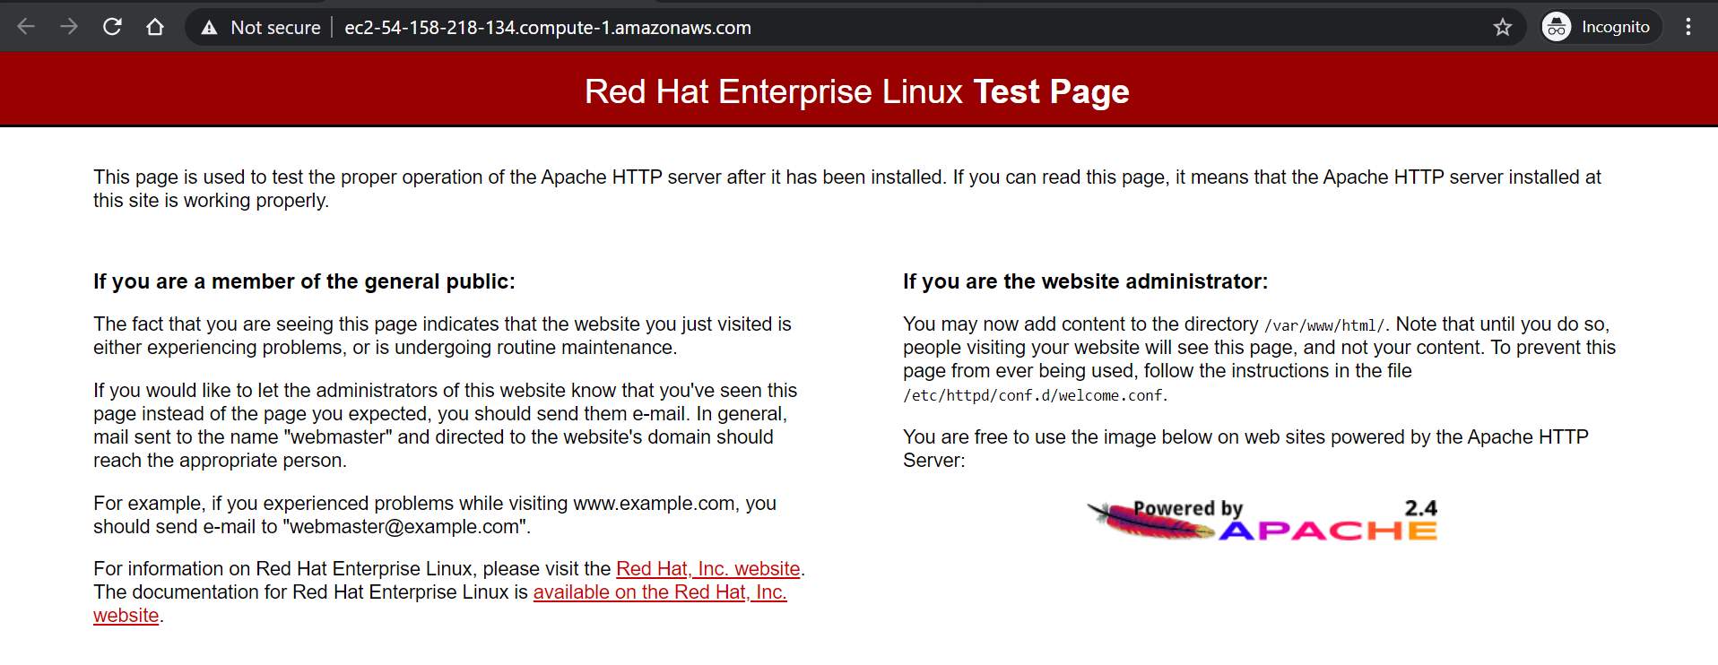

Mediawiki Home

